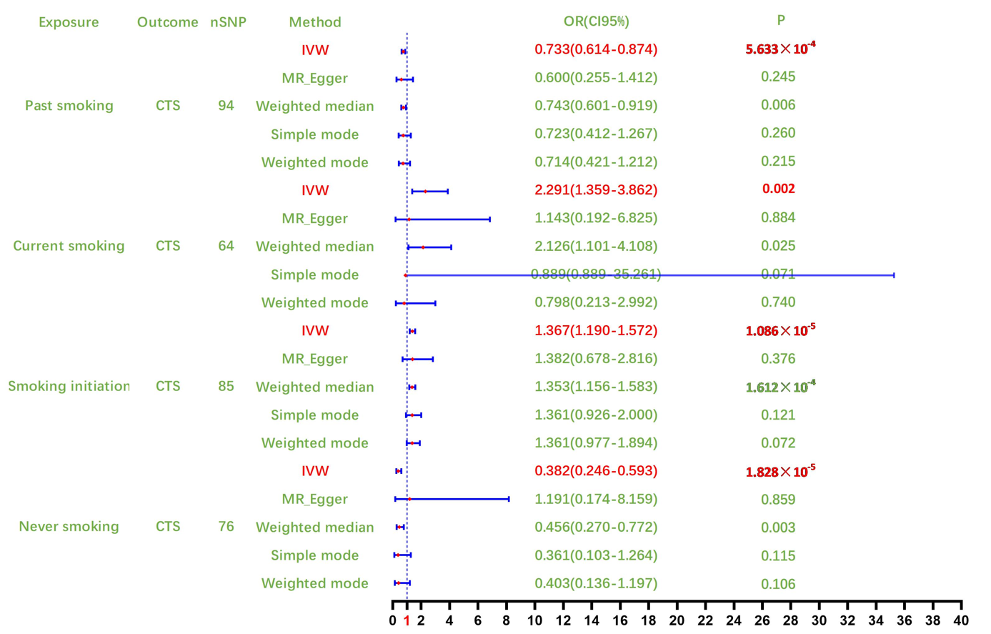

**Fig.S1** Summary of the results of the first causal analysis