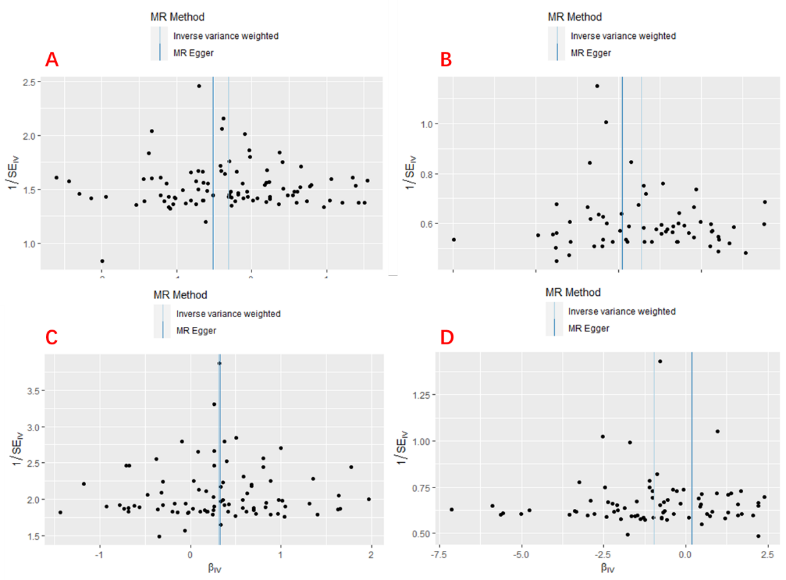

**Fig.S2** Funnel plot of four smoking behaviors and carpal tunnel syndrome.

(A) Past smoking ;(B)Current smoking;(C) Smoking initiation;(D) never smoking