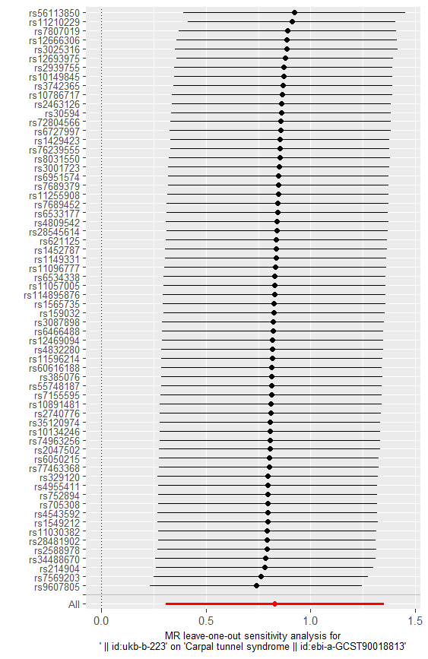

**Fig.S3** The results of the first analysis using leave-one-out method on current smoking and carpal tunnel syndrome.